Name:S.VIGNESH
Reg.No:192512378

17)Write a Prolog program to sum the integers from 1 to N.

Aim
To write and execute a Prolog program to calculate the sum of all integers from 1 to N using recursion.
Algorithm
- Start the program.
- Define the base case sum_n(0,0).
- Accept a positive integer N.
- Calculate N1 = N - 1.
- Recursively calculate the sum from 1 to N1.
- Add N to the recursively calculated sum.
- Store the final value in Sum.
- Display the sum.
- Stop.
PROGRAM:
% Program to find the sum of integers from 1 to N
sum_n(0, 0).
sum_n(N, Sum) :-
N > 0,
N1 is N - 1,
sum_n(N1, S1),
Sum is N + S1.

INPUT:
sum_n(10, Sum).
OUTPUT:
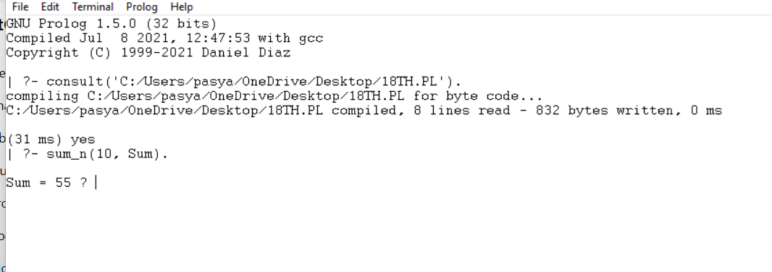

RESULT:
Thus, the Prolog program was successfully executed to calculate the sum of integers from 1 to N.

